**PROGRAMS:**

1. **Create a class called Box with three data members length, breadth, and height. Provide Set() and Get() functions for each data member.Also write a member function to calculate volume of a box.**

PROGRAM:

#include<iostream>  
#include<conio.h>  
using namespace std;  
class box {  
public:  
float l, b, h, v;  
void get() {  
cout << "Enter the length breadth and height of the box\n=>";  
cin >> l >> b >> h;  
}  
void set() {  
cout << "Length=" << l<<  endl;  
cout << "Breadth=" << b << endl;  
cout << "Height=" << h<< endl;  
}  
void calvol() {  
v = l*b*h;  
cout << "Volume=" << v<<endl;  
}  
};  
void main() {  
box ob1,ob2;  
ob1.get();  
ob1.calvol();  
ob1.set();  
cout << "\n";  
ob2.get();  
ob2.calvol();  
ob2.set();  
_getch();  
}

OUTPUT:

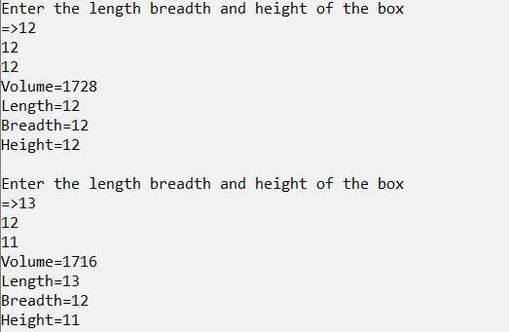

1. **Create a class called as Employee with data members first_name, last_name and monthly_salary. Provide set and get functions for each data member.Also write a member function that calculates yearly salary of an employee and displays it.**

PROGRAM:

#include<iostream>

#include<conio.h>

using namespace std;

class Employee {

public:

char first_name[20], last_name[20];

float monthly_salary, yearly_salary;

void get() {

cout << "Enter the First Name\n=>";

cin >> first_name;

cout << "Enter the Last Name\n=>";

cin >> last_name;

cout << "Enter the monthly salary\n=>";

cin >> monthly_salary;

cout << endl;

}

void out() {

cout << "First Name=" << first_name << endl;

cout << "Last Name=" << last_name << endl;

cout << "Monthly Salary=" << monthly_salary << endl;

}

void yearly()

{

yearly_salary = monthly_salary * 12;

cout << "Yearly Salary=" << yearly_salary << endl;

}

};

main()

{

Employee harsh,harsha;

harsh.get();

harsh.out();

harsh.yearly();

cout<<endl;

harsha.get();

harsha.out();

harsha.yearly();

_getch();

}OUTPUT:

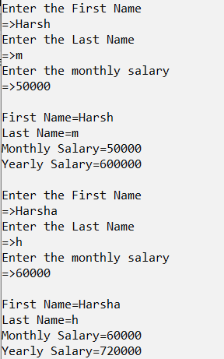

1. **Write a object-oriented C++ program to create a library information system containing the following for all books in the library: accession number, name of author, title of book, year of publication, publishers name, cost of book. Find the most expensive book.**

PROGRAM:

#include<iostream>

#include<conio.h>

using namespace std;

class library

{

int acc_number, year, cost;

char p_name[70], name[70];

char title[70];

public:

void get()

{

cout << "Name of the author \n:" << name;

cout << "Year of publication \n:" << year;

cout << "Name of book \n:" << title;

cout << "Publishers name:" << p_name;

cout << "Name of accession number \n:" << acc_number;

}

void set()

{

cout << "\nEnter name of the author:";

cin >> name;

cout << "Enter the year of publication:";

cin >> year;

cout << "Enter name of the book:";

cin >> title;

cout << "Enter publishers name:";

cin >> p_name;

cout << "Enter accession number:";

cin >> acc_number;

cout << "Enter the cost:";

cin >> cost;

}

friend void max(library, library, library);

};

int main()

{

library l1, l2, l3;

cout << "l1 is used\n";

l1.set();

cout << "l2 is used\n";

l2.set();

cout << "\n l3 is used";

l3.set();

l1.get();

l2.get();

l3.get();

max(l1, l2, l3);

_getch();

return 0;

}

void max(library x, library y, library z)

{

if (x.cost > y.cost && x.cost > z.cost)

cout << "\n Book in l1 is most expensive:";

else

{

if (y.cost > x.cost && y.cost > z.cost)

cout << "book in l2 is most expensive";

else cout << "Book in l3 is most expensive";

}

}

OUTPUT:

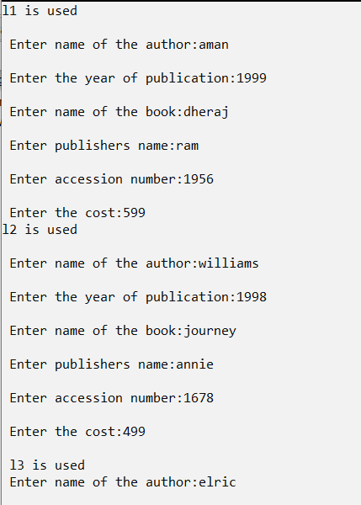

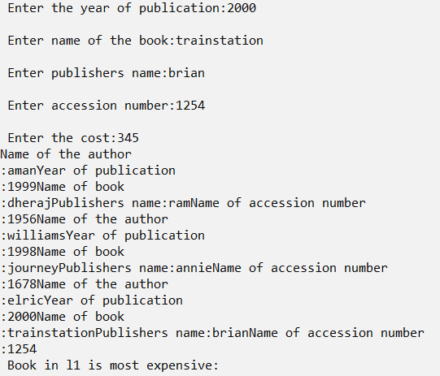

1. **Write a C++ Program to Calculate Electricity Bill of a user using Class. Tariff is as follows: 100 Rs. 1.20 per unit; 200 Rs. 2 per unit; 300 Rs. 3 per unit.**

PROGRAM:

#include<iostream>  
#include<conio.h>  
using namespace std;  
class Bill {  
public:  
float customer_no, units,bill;  
char customer_name[20];  
void get() {  
cout << "Enter the Customer No.\n=>";  
cin >> customer_no;  
cout << "Enter the Customer Name\n=>";  
cin >> customer_name;  
cout << "Enter the Units\n=>";  
cin >> units;  
cout << endl;  
}  
void set() {  
cout << "Customer No.=" << customer_no << endl;  
cout << "Customer Name=" << customer_name << endl;  
cout << "Units=" << units << endl;  
}  
void calbill() {  
if (units <= 100)  
bill = units*1.20;  
else if (units <= 300)  
bill = 100 * 1.20 + (units - 100) * 2;  
else  
bill = 100 * 1.20 + 200 * 2 + (units - 300) * 3;  
cout << "bills=" << bill<<endl;  
}  
};  
void main() {  
Bill harsh, harsha;  
harsh.get();  
harsh.calbill();  
harsh.set();  
cout << "\n";  
harsha.get();  
harsha.calbill();  
harsha.set();  
_getch();  
}

OUTPUT:

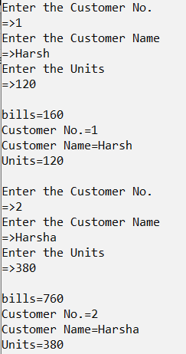

1. **Write an object-oriented C++ program to add time**

PROGRAM:

#include<iostream>  
#include<conio.h>  
using namespace std;  
class time {  
public:  
int min, hr;  
void get() {  
cout << "Enter the hours and minutes:\n";  
cin >> hr >> min;  
cout << endl;  
}  
void put() {  
cout << "=>" << hr << " hours "<<min<<" minutes\n";  
}  
void add(time a1, time a2) {  
min = a1.min + a2.min;  
hr = min / 60;  
min = min % 60;  
hr = hr + a1.hr + a2.hr;  
put();  
}  
};  
void main() {  
time a1, a2,a3;  
a1.get();  
a2.get();  
a3.add(a1, a2);  
_getch();  
}

OUTPUT:

